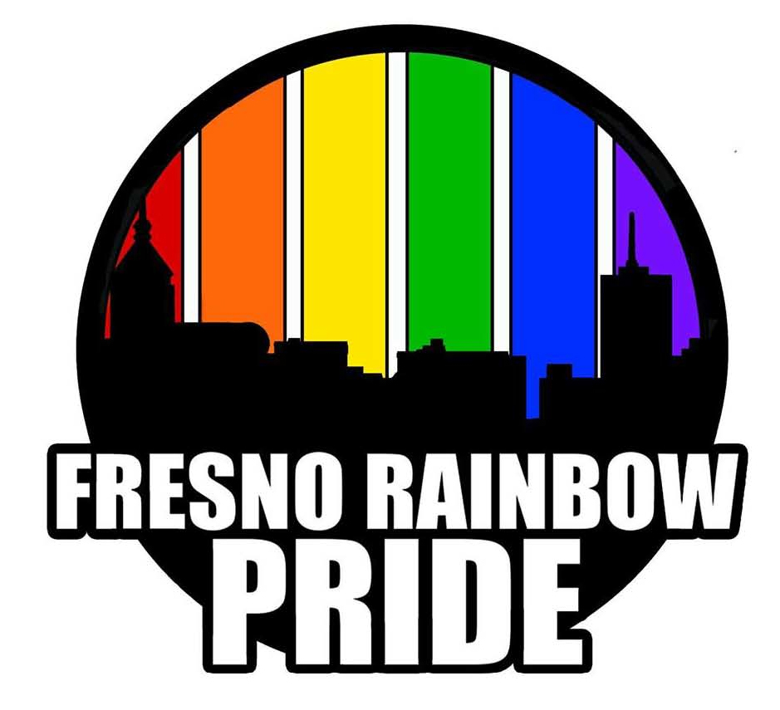Dear Pride Partners: March 12, 2019

It is once again that time of the year to renew your support of the Valley’s largest LGBT pride celebration. Fresno Rainbow Pride is now closing in its 29th anniversary, on Saturday June 1st, 2019.

Your annual support of this dynamic one-day gathering of the Valley’s LGBT communities and our allies is by far the most successful LGBT event of the year. Our success is due to your continued financial support of the Pride Parade and Festival.

Last year we established the goal of creating a sustainable legacy that will carry us through the next decade. We are continuing our commitment towards this endeavor of creating a Pride celebration that will be financially healthy for future Prides to come.

I am a firm believer in this one fact, that you, our Pride Partners, are our most valuable resource. The Pride Partners are our core source of support. Your generous financial contributions sustains a vibrant, all ages, open and an accessible community event that celebrates the accomplishments of the LGBT Community.

Once again, I am asking you to continue the support that you have shown us over the years as a contributor toward sustaining what we have jointly built for the past 29 years.

Your financial support is vital to secure a healthy future for Fresno’s LGBT Pride Celebration. Each year we attempt to grow our “seed fund” to give us a better start for the next parade and festival. The theme of this year’s Pride Parade and Festival is “2GETHER.” Your donations this year will help us create a great 29th annual Pride Parade and Festival and give us a good running start for next year’s 30th celebration in 2020.

Renewing your Pride Partnership will enable us to encourage more festive parade entries that will bring fun, excitement and vibrant color to the procession down Olive Avenue. We will be able to bring bigger name entertainers to the festival, and create a more relaxing and comfortable environment in which to spend your Pride day with us at the official Pride festival.

Your donations more importantly with help recharge the batteries of LGBT family members who often do not have emotional support in this very conservative Valley. Being a Pride Partner allow us to keep the whole event affordable, accessible and open to our whole community, by keeping the parade entry fees reasonable and the festival admission costs down for everyone. Additionally, we can grow our attractions and activities for children, teens, young adults and our graying seniors.

You can renew your Pride Partnership by making a donation by writing us a check today or by visiting at our website www.fresnorainbowpride.com and making a donation via PayPal.

JOIN US! “2GETHER…we can do this!” Donate today for the 29th Annual Fresno Rainbow Pride! Community Link is a 501(c) 3 nonprofit community service organization and your donation is tax deductible. Donations via a check should be made out to Community Link. Send your check to: Community Link's Fresno Rainbow Pride, P.O. Box 4959, Fresno, Ca. 93744

Thank you for all of your support! In Pride,

Jeffery Robinson, Fresno Rainbow Pride Coordinator